**SCS 3212 - Mobile Application Development**

Lab Sheet 03

Question 1:

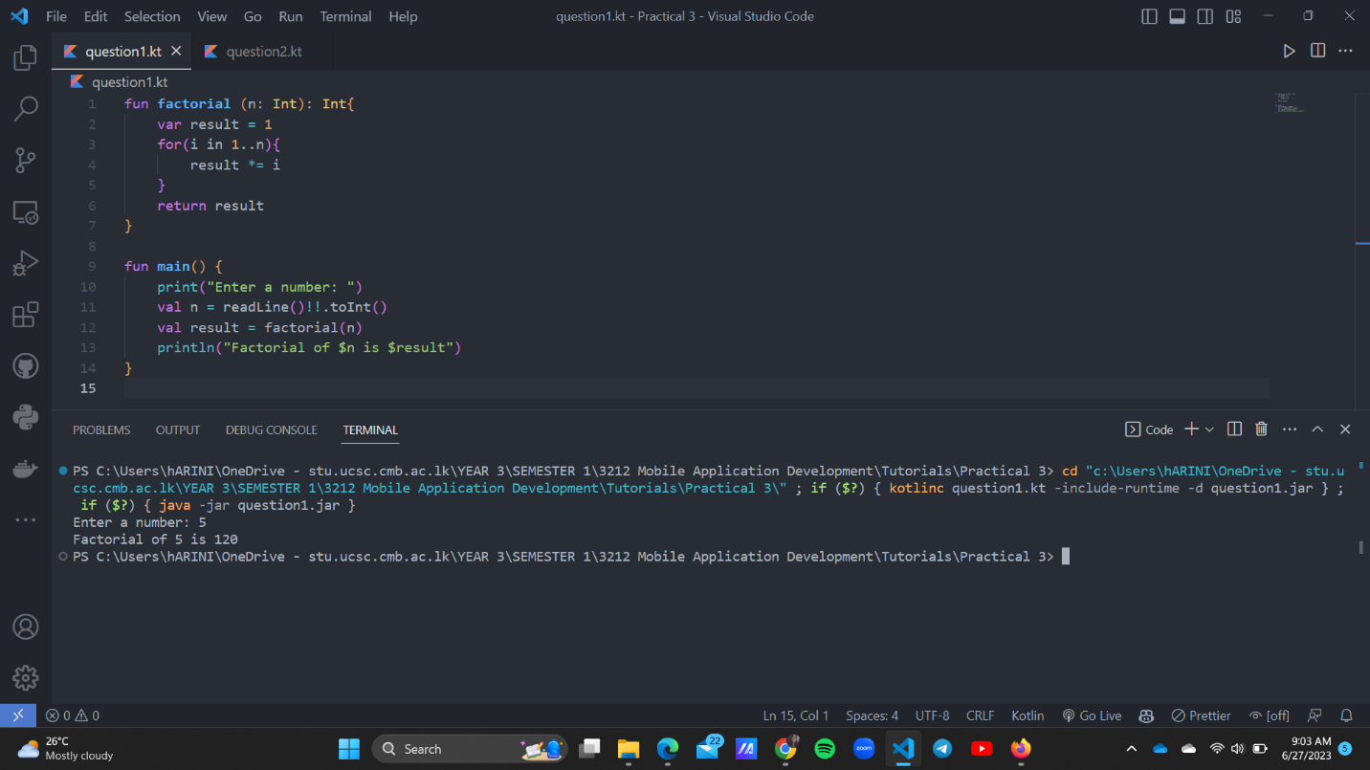

Question 2:

Question 3:

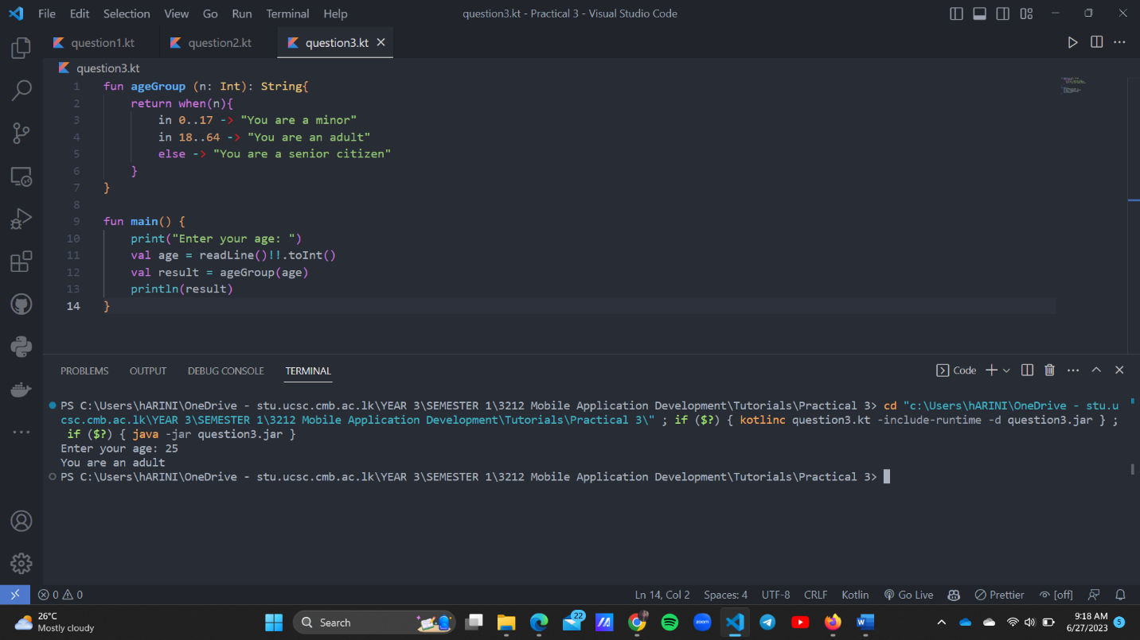

Question 4:

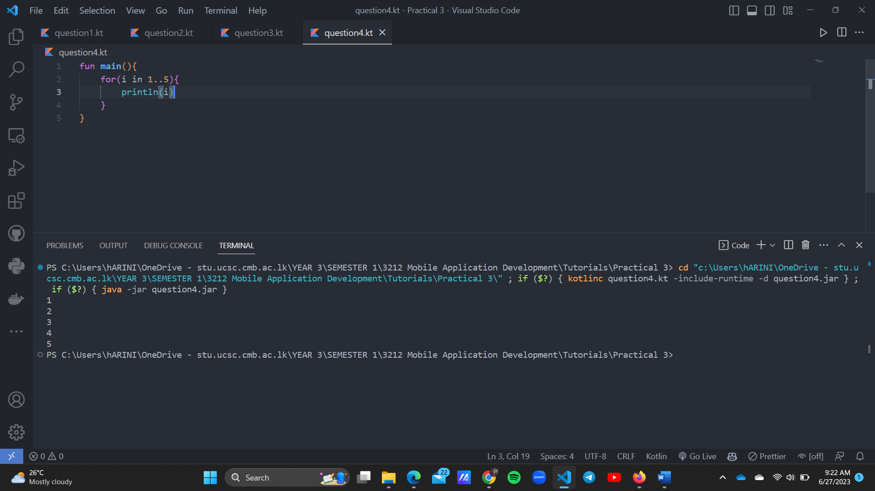

Question 5:

